Antonio Scalfaro

Design-Template – Wk6 Password Checker, strings

**Requirements:**

Create a python program to check if a password is valid or not. It should contain three separate functions to check for: length of password (between 6 – 15 characters), at least one digit and one alphabetical character are present, does not contain any white spaces. The program should let the user know the first invalid property of the password if there are multiple.

**Design:**

* **welcomeMessage()**
  + print out welcome message and program details
* **checkLen(password)**
  + return (len(password) < 6 or > 15)
* **checkCharDigit(password)**
  + digitCount = sum(c.isdigit() for c in password)
  + alphaCount = sum(c.isalpha() for c in password)
  + return (alphaCount < 1 or digitCount < 1)
* **checkSpace**
  + return (‘ ‘ in password)
* **main()**
  + welcomeMessage()
  + password = user input
  + if conditional to check validity
  + if(checkLen(password))
    - print invalid length
  + elif(checkCharDigit(password))
    - print invalid, at least one digit and one alpha
  + elif(checkSpace(password))
    - print invalid, no white space allowed
  + else
    - print valid password
* Execute main()

**Test Plan:**

|  |  |  |
| --- | --- | --- |
| **Test Case #** | **Input** | **Expected Output** |
| **1** | **Thisisvalid1** | **Valid password** |
| **2** | **This isinvalid1** | **Invalid, no white space** |
| **3** | **123456** | **Invalid, no alpha char** |
| **4** | **notvalid** | **Invalid, no digit char** |
| **5** | **Invalidformorethan onecase** | **Invalid, character limit** |
| **6** | **Invalid> one** | **Invalid, no digit char** |
| **7** | **notva** | **Invalid, character req** |

**Test 1:**

**Test 2:**

**Test 3:**

**Test 4:**

**Test 5:**

**Test 6:**

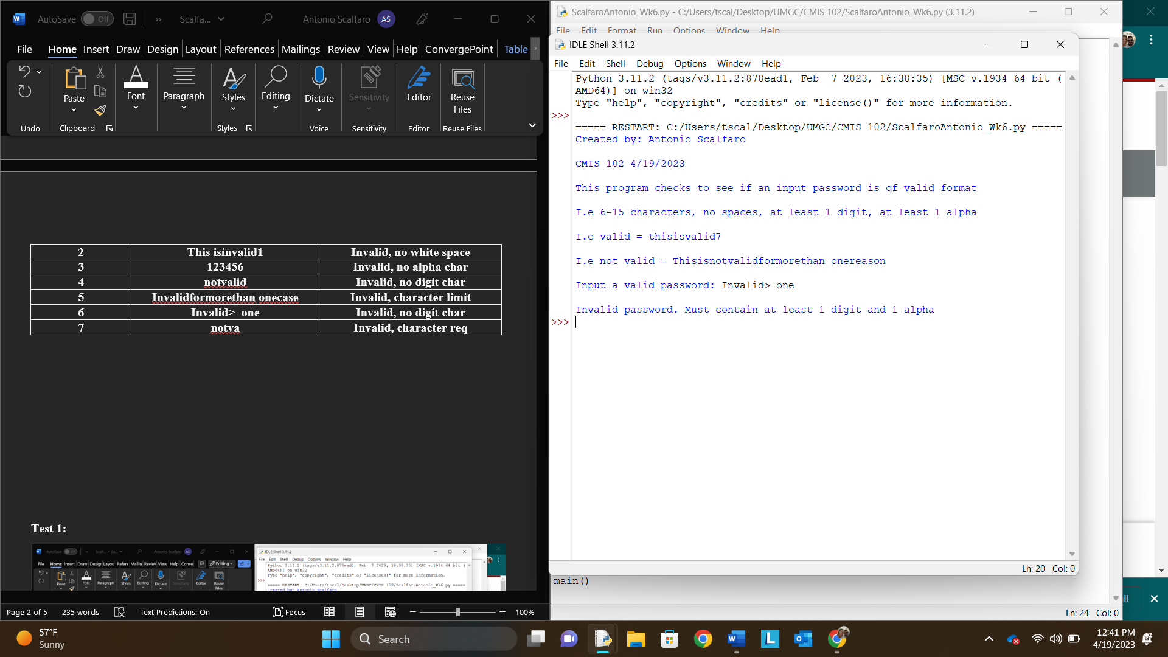

**Test 7:**

